OBJECT ORIENTED MODELING AND DESIGN -June 2024
PART A
1. Describe the difference between aggregation and composition in object-oriented modelling.
Aggregation and composition are two types of relationships between objects in object oriented modeling. They are both used to represent a "has-a" relationship between two classes, but they differ in the strength of the relationship.
Aggregation is a weak relationship between two classes. This means that the child class can exist independently of the parent class. For example, a student can exist without a class. The student is said to be "aggregated" by the class.
Composition is a strong relationship between two classes. This means that the child class cannot exist independently of the parent class. For example, a room cannot exist without a house. The room is said to be "composed" of the house.
2. Explain how object-oriented programming promotes code reusability and maintainability.
Features of OOP that Promote Reusability and Maintainability are
• Classes: A class is a template that consists of the data members or variables and functions and defines the properties and methods for a group of objects.
• Interfaces: allows a class to inherit the properties and methods of another class called the parent class, the base class, or the super-class.
• Abstract classes: An abstract class is a template for a class that contains methods and variables, and is used as a base class for other classes to extend from
Key Principles of OOP
• Encapsulation:- Bundles data and methods into a single unit called an object, hiding internal details and only exposing what's necessary.
• Inheritance:- Allows a class to inherit properties from other classes, reducing the need to retype class features.
• Polymorphism: The word polymorphism means to have many forms. So, by using polymorphism, you can add different meanings to a single component.
3. Explain the concept of concurrency in dynamic modeling and its challenges.
Concurrency in dynamic modelling refers to the ability of multiple objects or components within a system to execute independently and simultaneously. Challenges of Concurrency in Dynamic Modeling are Synchronization,Deadlock,Race Condition,-Debugging and Testing
4. Describe the relationship between object and dynamic models in software development.
Object models represent the static structure of a software system, focusing on the classes, attributes, and relationships between objects. Dynamic models represent the behavior of a software system, capturing how objects interact and respond to events over time.
Dynamic model specifies the allowable sequences of changes to objects from the object model Dynamic model structure is related to and constrained by object model structure.A hierarchy of states of an object is equivalent to a restriction hierarchy of the object class. Obiect oriented models and languages do not usually support restriction in the generalization hierarchy, so the dynamic model is the proper place to represent it. The dynamic model of a class is inherited by its subclasses.States are defined by the interaction of objects and events.Transitions can be implemented as operations on objects.Operation name corresponds to event name.

5. Describe the concept of interface format in dynamic modeling.
In dynamic modeling, an interface format defines the structure and rules for exchanging data and messages between different components or models. It acts as a standardized communication protocol that ensures consistent interaction and data exchange, enabling seamless integration of various components within the dynamic model.
Most interactions can be separated into two parts- application logic and user interface. Analysis should concentrate first on the information flow and control, rather than the presentation format. Same program logic can accept input from command lines, files,mouse buttons, touch panels, physical push buttons, or carefully isolated. Dynamic model captures the control logic of the application. It is hard to evaluate a user interface without actually testing it. Often the interface can be mocked up so that users can try it. Application logic can often be simulated with dummy procedures. Decoupling application logic from user interface allows look and feel of the user interface to be evaluated while the application is under development.
6. Explain the significance of identifying events in dynamic modeling.
Identifying events is crucial in dynamic modeling because events represent significant occurrences that trigger changes in the system's state or behaviour. By explicitly defining events and their implications, modellers can capture the dynamic nature of the system and effectively represent its real-world behaviour.
Examine the scenario to identify all external events. Events include all signals, inputs,decisions, interrupts, transitions, and actions to or from users or external devices. Internal computation steps are not events, except for decision points that interact with the external world .Use scenarios to find normal events, but don’t forget error conditions and unusual events. An action by an object that transmits information is an event. Most object to object interaction and operations correspond to events. Group together under a single name events that have the same effect on flow of control, even if their parameter values differ. Sometimes an object sends an event to itself, in which case the event is both an output and input for the same class.
7. How the design optimization is performed?
- During design optimization, the designer must perform the following tasks:
- Add Redundant Associations for Efficient Access
- Rearranging Execution Order for Efficiency
- Saving Derived Attributes to Avoid Recomputation

8. How the inheritance can be adjusted?
Inheritance can be adjusted by
- Rearrange classes and operations
- Abstracting Out Common Behavior
- Use Delegation to Share Implementation

9 What are use cases and actors? Explain the use case diagram for an entry subsystem.
A use case is a sequence of actions that a system performs to complete a specific task. It
is typically written from the perspective of the user and describes the steps that the user
takes to achieve a goal.

An actor is a person, organization, or other external system that interacts with the system. Actors can be either primary or secondary. Primary actors are the main users of the system, while secondary actors are other systems that interact with the system.
Use case diagrams are a type of UML diagram that shows the use cases and actors in a system. They are a useful tool for understanding the requirements of a system and for designing its user interface.
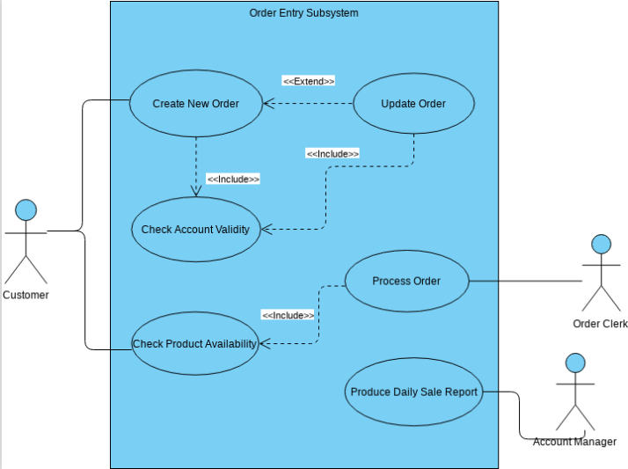
10. Discuss about class diagram and state diagram introduced by Grady Booch's object-oriented analysis and design methodology
Class Diagrams: Define the classes that represent the blueprints for creating objects, specifying their attributes, methods, and relationships. A graphical representation of the static view of the system and represent different aspects of the application.A collection of class diagrams represent the whole system.Show the existence of classes and their relationships in the logical view of the system.The class diagram is the main building block of object-oriented modeling. It is used for general conceptual modeling of the structure of the application, and for detailed modeling, translating the models into programming code.Class diagrams can also be used for data modeling.
State Diagrams: Model the dynamic behavior of objects, illustrating how they transition between states in response to events
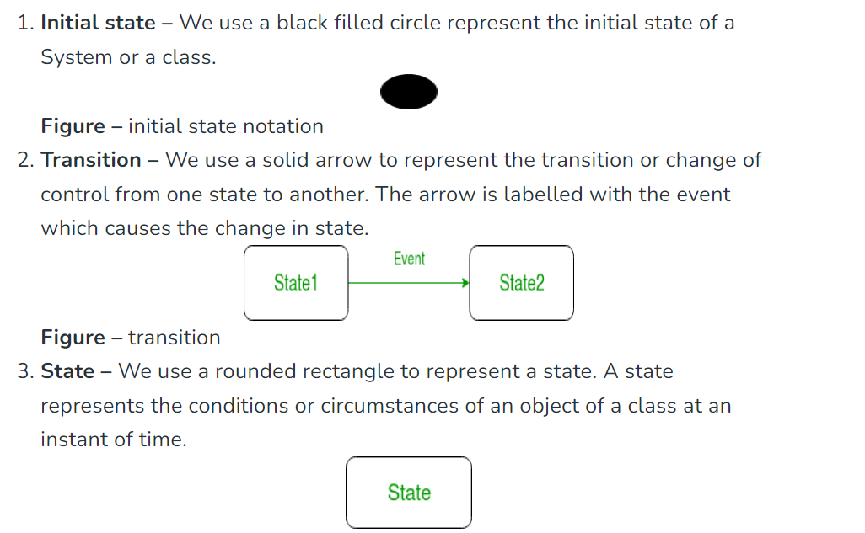
4.
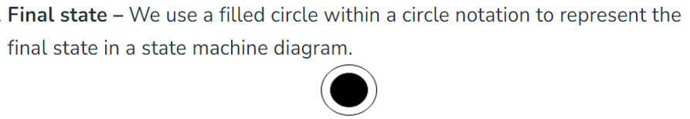
PART B
Module -2

11 a) Discuss the role of encapsulation, inheritance, and polymorphism in achieving code modularity, reusability, and flexibility in object-oriented programming.(14)
Encapsulation encapsulates data and methods within an object, protecting the internal data from
external interference and ensuring data integrity. This promotes modularity.
  - It can also be called as information hiding.
  - It consists of separating the external aspects of an object, which are accessible to other objects, from the internal implementation details of the object, which are hidden from other objects.
  - It prevents program from becoming so interdependent that a small change has massive ripple effect.
  - The implementation of an object can be changed without affecting the applications that use it.
  - It gives the ability to combine data structure and behavior in a single entity.

Inheritance allows new classes to inherit properties and methods from existing classes, creating a hierarchy of related classes. This promotes code reusability by eliminating the need to duplicate code for similar functionalities. Inheritance hierarchy helps organize code in a structured manner, making it easier to maintain and update.

Polymorphism enables objects of different classes to respond to the same method call in
different ways. This polymorphism allows for dynamic behavior and makes code more adaptable
to changes in the system.
These principles contribute to code modularity, reusability, and flexibility:

OR
12 a) Differentiate between encapsulation and information hiding in object-oriented programming.(7)
Data hiding helps prevent the illegal access of members of a class, while encapsulation helps in the wrapping up of data members and methods inside a class.
Encapsulation and information hiding are closely related concepts in object-oriented programming (OOP), Encapsulation is the process of bundling data and methods that operate on that data within a single unit, Information hiding, is a specific aspect of encapsulation that emphasizes protecting the internal data of an object from unauthorized access or modification In simpler terms, encapsulation is the "what" and "how" of data protection, while information hiding is the "why" and "when". Encapsulation provides the mechanism
b)2. Explain the role of polymorphism in supporting dynamic dispatch in object oriented programming.(7)
The call to an overridden method is resolved dynamically at runtime rather than at compile-time.
Polymorphism, determines which method to execute based on the runtime type of an object. Dynamic dispatch enables objects of different classes to respond to the same method call in different ways, promoting code flexibility and adaptability.

Polymorphism allows for different classes to implement the same method with different behaviors.

Dynamic dispatch, in conjunction with polymorphism, makes this possible by determining the method implementation at runtime.

The benefits of using polymorphism with dynamic dispatch are:Flexibility, Reusability, Maintainability.
Module -2
13 a) Discuss the significance of dynamic modeling and Nested state diagrams with suitable example.(14)
Dynamic Modeling
Dynamic models capture the system's behavior over time, including its interactions with users, external systems, and the environment.
- The dynamic model shows the time-dependent behaviour of the system and the objects in it.
- A system can be understood by first examining its static structure, that is, the structure of its objects and relationship to each other at a single moment in time.
- Then we examine changes to the objects and their relationship over time. Those aspects of a system that are concerned with time and changes are the dynamic model.
- The dynamic model is a collection of state diagrams that interact with each other via shared events.
Nested State Diagram
- A nested state diagram is used to model the complex system as the regular state diagram is inadequate in describing the large and complex problem.
- A complex system has much redundancy and this redundancy can be resolved by restructuring the complex system.
- One method to restructure complex system is to expand the state that has certain sub states.
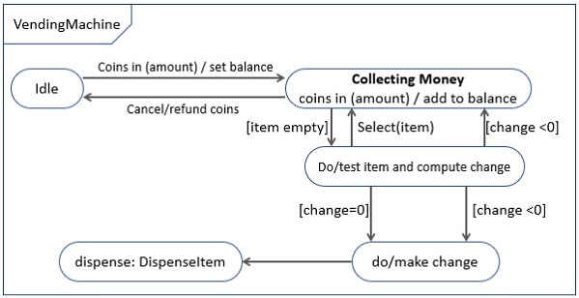

- The state dispense may have multiple substates so it is expanded in the lower level state diagram, which is also termed as submachine.
- Submachine is defined as a state diagram which is triggered by another high-level state diagram.
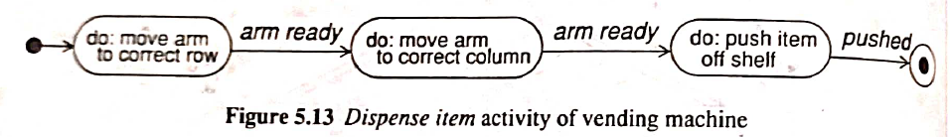
- Events can also be expanded into subordinate state diagrams.
- The select item event actually involves several low-level events.
- The customer keys in an item number and can start over by hitting clear; the selection is confirmed by hitting enter. The label on the bull's-eye indicates the event generated on the higher-level state diagram.
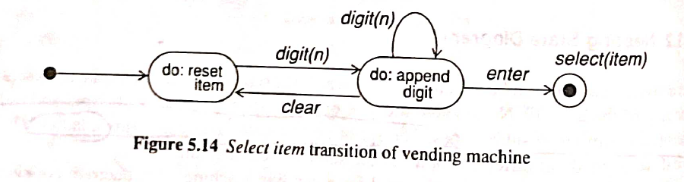
When a state has multiple sub states then they could be nested and enclosed in a contour and could be labelled as the composite state name.

OR
14 a) Explain the role of events and states in dynamic modeling. (14)
In dynamic modeling, events and states representing the behaviour of software systems.

EVENTS
- An event is something that happens at a point in time.
- We can understand an event as some action oriented result, such as mouse click. Whenever you will click on a mouse, the appropriate action takes place.
- An event has no duration.
- An event is simply an occurrence.
- An event is actually a one way transmission of information from one object to another, but some times it may be that an event that occurs on a single object and changes the state of that object.
- Two events can take place at the same time, one after the other, or both the events independently of each other and occurring simultaneously.(causally related-before ,after)
- Eg: Two trains can depart at the same time for two different places, or two can depart from the same place, but one after the other. It means that the two events can be independent as well as dependent on each other.
- Two events which are unrelated and occur at the same time are known as concurrent events. They have no effect on each other.
- We cannot find particular order between the two events, because they can occur in any order.
- An object sending an event to another object may expect a reply, but the reply will be a separate event of the second object. So, you may see conversations between two objects as a combination of two or more events.
- Every event is a unique occurrence, but we group them into event classes and give each event class a name to indicate common structure and behavior
- Eg: Events like train departs which has the attributes train number, class, city, etc. It is not necessary that all the attributes of objects contribute to attributes of events.
- Events include error conditions as well as normal occurrences. Eg: motor jammed, transaction aborted, and time out are typical error events.

STATES
- A state corresponds to the interval between two events received by an object. Event represents points in time ; states represent ientrynterval of time.
- For example, after the receiver is lifted and before the first digit is dialed, the phone line is in state dial tone.
- A state has duration. It occupies an interval of time.
- A state is often associated with a continuous activity such as the ringing of telephone or an activity that takes time to complete, such as flying from Chicago to San Francisco.

- A state diagram relates events and states.
- When an event is received , the next state depends on the current state as well as the event.
- A change of state caused by an event is called a transition.
- A state diagram is a graph whose nodes are states and whose directed arcs are transitions labeled by event names.

Module -3
15 a) Discuss the concept of functional modeling and its role in defining the functional
requirements of software systems.
Functional modeling is a software development technique that focuses on defining the functions and behavior of a system without considering its implementation details

Functional Modeling
- The functional model shows how values are computed, without regard for sequencing, decisions or object structure.
- It shows which values depend on which other values and which function relate them.
- The DFDs are useful for showing functional dependencies .
- Functions are expressed in various ways, including natural language, mathematical equations and pseudo code.
- Processes on DFD corresponds to activities or actions in the state diagrams of the class.
- Flows on DFD correspond to objects or attribute values in object diagram.
- Construct the functional model after the two models.

Steps performed in constructing functional model:
- Identifying input and output values
(i) Identifying input and output values
  - List input and output values. (parameters of events between system and outside world.)
  - Find any input or output values missed.
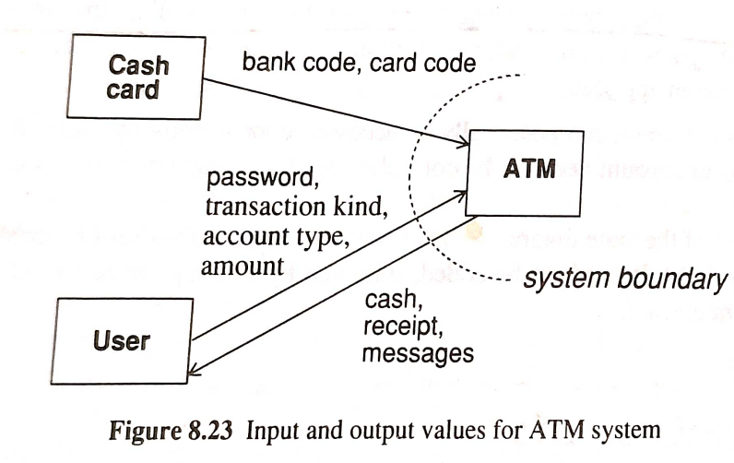
(ii) Building DFD
- Now construct a DFD, showing how each output value is computed from input values.
- A DFD is usually constructed in layers.
- The top layer may consist of a single process, or perhaps one process to gather inputs, compute values, and generate outputs.
- Within each DFD layer, work backward from each output value to determine the function that computes it.
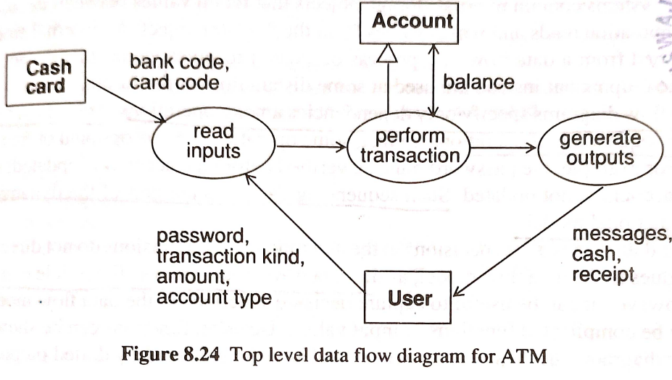
- If the inputs to the operations are all inputs of the entire diagram, you are done; otherwise some of the operation inputs are intermediate values that must be traced backward in turn.
- You can also trace forward from inputs to outputs, but it is usually harder to identify all users of an input, than to identify all the sources of an output
- Expand each non trivial process in the top level DFD into a lower level DFD.
- Most systems contain internal storage objects that retain values between iterations.
- An internal store can be distinguished from a data flow or a process because it receives values that don’t result in immediate outputs but are used at some distant time in the future.
- The DFD show only dependencies among operations. They don’t show decisions.(control flows)
- iii) Describing Functions
- When the DFD has been refined enough, write a description of each function.
- The description can be in natural language, mathematical equations, pseudocode, decision tables, or some appropriate form.
  - Focus on what the function does, and not how it is implemented.
  - The description can be declarative or procedural.
  - A declarative description specifies the relationships between input and output values and the relationships among output values.
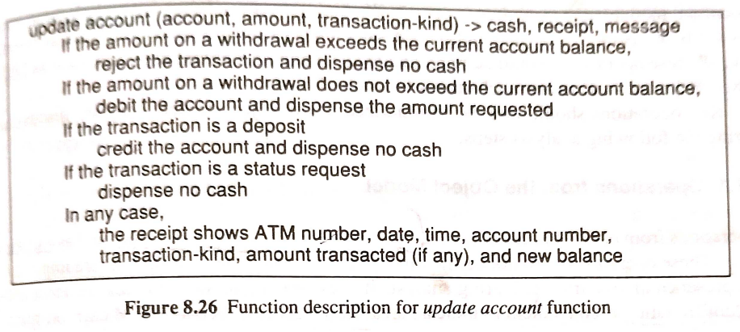
OR
16 a)4. Explain the concept of system design and its role in translating software
requirements into a high-level system architecture.(14)
System design is a crucial phase in the software development process that bridges the gap between abstract software requirements and tangible system architecture.

System design is the high-level strategy for solving the problem and building a solution. The steps
involved in system design are:
1. Estimating system performance
  - Prepare a rough performance estimate to achieve high accuracy, but simply to determine if the system is feasible.
2. Making a reuse plan
- There are 2 different aspects of reuse –
1.using existing things and
2. creating reusable new things.
- It is much easier to reuse existing things than to design new things.
- Reusable things include models, libraries, patterns, frameworks etc.

The system designer must make the following decisions:
- Organize the system in to subsystems.
- Identify concurrency inherent in the problem.
- Allocate subsystem to processors and tasks.
- Choose an approach for management of data store.
- Handle access to global resources.
- Choose the implementation of control in software.
- Handle boundary conditions.
- Set trade-off priorities. (write any four)

Breaking a system into subsystems
- First step of system design is to divide the system in a small number of subsystems.
- Each subsystem encompasses aspects of the system that share some common property such as similar functionality, same physical location, execution on same kind of hardware.
- A subsystem is a package of classes, associations, operations, events and constraints interrelated and have a well defined small interface with other subsystems.
- Subsystems are identified by the services it provides.
- Determining subsystems allow a division of labor so each can be designed by a separate team
- Most interactions should be within subsystems rather than across boundaries and it reduces dependencies among subsystems.
- Relationship between two subsystems can be client-supplier or peer-to-peer.
- In a client-supplier relationship, the client calls on the supplier for service. Client must know the interface of the supplier but not vice versa.
- In a peer-to-peer relationship, each can call on the other and therefore they must know each others interfaces.
- One way communication (client-supplier) is much easier to build, understand and change than two way (Peer-to-Peer).
- The decomposition of systems into subsystems may be organized as a sequence of layers or partitions.
1.LAYERS
- A layered system is an ordered set of virtual worlds, each built in terms of the ones below it and providing the basis of implementation for the ones above it.
- The objects in each layer can be independent , although there is often some correspondence between objects in different layers.
- Knowledge is one way only: A subsystem knows about the layers below it , but has no knowledge of the layers above it.
- Layered architecture come in two forms: closed and open
- In closed architecture, each layer is built only in terms of the immediate lower layer. This reduces the dependencies between the layers and allows changes to be made most easily because a layer’s interface only affect the next layer.
- In an open architecture, a layer can use features of any lower layer to any depth. This reduces the need to redefine operations at each level, which can result in a more efficient and compact code.
- Usually only the top and bottom layers are specified by the problem statement: the top is the desired system, the bottom is the available resources.
2.PARTITIONS
- Partitions vertically divide a system in to several independent or weakly coupled subsystems, each providing one kind of service.
- For example, a computer operating system includes a file system, process control, virtual memory management, and device control.
- The subsystems may have some knowledge of each other, but this knowledge is not deep, so major dependencies are not created.
- A system can be successively decomposed into subsystems using both layers and partitions in various possible combinations: Layers can be partitioned and partition can be layered.
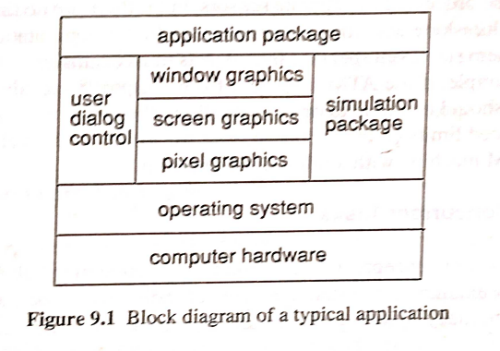
3.System Topology
- When the top level subsystems are identified, the designer should show the information flow among subsystems with a data flow diagram. Sometimes, all subsystems interact with all other subsystems, but often the flow is simpler.
- For example, many computations have the form of pipeline; a compiler is an example. Other systems are arranged as a star, in which a master subsystem controls all interactions with other subsystems. Use simple topologies when they are suitable for a problem to reduce the number of interactions among subsystems.
Identifying Concurrency
- Two objects are said to be inherently concurrent if they can receive events at the same time without interacting.
- If the events are unsynchronized, the objects cannot be folded into a single thread of control. (engine and wing control on an airplane must operate concurrently)
- Two subsystems that are inherently concurrent need not necessarily be implemented as separate hardware units.
- The purpose of interrupts, Operating System and tasking mechanism is to simulate logical concurrency in a uniprocessor - so if there are no timing constraints on the response then a multitasking Operating System can handle the computation.
- All objects are conceptually concurrent, but many objects are interdependent.
- By examining the state diagram of individual objects and the exchange of events between them, many objects can be folded into a single thread of control.
- A thread of control is a path through a set of state diagrams on which only a single object at a time is active - thread remains in a state diagram until an object sends an event to another object and waits for another event.
- On each thread of control only a single object is active at a time.
- Threads of control are implemented as tasks in computer systems.
Allocating Subsystems To Processors & Tasks
- Each concurrent system must be allocated to a h/w unit-general purpose processor or a specialized functional unit.
1.Estimating Hardware Resource Requirements
- The decision to use multiple processors or hardware functional units is based on the need for higher performance than a single CPU can provide (or fault tolerant requests).
- Numbers of processors determine the volume of computations and speed of the machine.
- The system designer must estimate the required CPU power by computing the steady state load as the product of the number of transactions per second and the time required to process a transaction.
- Experimentation is often useful to assist in estimating.
2.Hardware/Software Tradeoffs
- Hardware can be viewed as a rigid but highly optimized form of software.
- The system designer must decide which subsystems will be implemented in hardware and which in software.
- Subsystems are in hardware for 2 reasons:
  - Existing hardware provides exactly the functionality required – e.g. floating point processor
  - Higher performance is required than a general purpose CPU can provide.
- Compatibility, cost, performance, flexibility are considerations whether to use hardware or software.
- Software in many cases may be more costly than hardware because the cost of people is very high.
- Hardware is much more difficult to change than software.
3.Allocating Tasks To Processors
Tasks are assigned to processors because:
  - Certain tasks are required at specific physical locations
  - Response time or information flow rate exceeds the available communication bandwidth between a task and a piece of hardware.
  - Computation rates are too great for single processor, so tasks must be spread among several processors.
4.Determining Physical Connectivity
  - Choose the topology of connecting the physical units.
  - Choose the topology of repeated units.
  - Choose the form of connection channels &the communication protocols.
Management Of Data Stores
  - The internal and external data stores in a system provide clean separation points between subsystems with well defined interfaces.
  - Data stores may combine data structures, files, and database implemented in memory or on secondary storage devices.
  - The different data stores provide trade-offs between cost, access time, capacity and reliability.
  - Files are cheap, simple and permanent form of data store.
  - File operations are low level and applications must include additional code to provide a suitable level of abstraction.
  - File implementations vary from machine to machine so portability is more difficult.
  - Databases are powerful and make applications easier to port.
  - Databases do have a complex interface and may work awkwardly with programming languages.
- The kind of data that belongs in a Database:
    - Data that requires access at fine levels of detail by multiple users
    - Data that can be efficiently managed by DBMS commands
    - Data that must be ported across many hardware and operating system platforms
    - Data that must be accessible by more than one application program.

- The kind of data that belongs in a file & not in a relational DB:
    - Data that is voluminous but difficult to structure within the confines of a Database.
    - Data that is voluminous in quantity and of low information density (debugging data, historical files)
    - Raw data that is summarized in the Database
    - Volatile data that is kept a short time and then discarded.
1.Advantages of using a Database
  - Handles crash recovery, concurrency, integrity
  - Common interface for all applications
  - Provides a standard access language - SQL
2. Disadvantages of using a Database
  - Performance overhead
  - Insufficient functionality for advanced applications - most databases are structured for business applications.
  - Awkward interface with programming languages.
Handling Global Resources
  - The system designer must identify the global resources( processors, tape drives, etc) and determine mechanisms for controlling access to them .
  - If the resource is a physical object, it can control itself by establishing a protocol for obtaining access within a concurrent system.
  - If the resource is logical entity (object ID) there is a danger of conflicting access in a shared environment.
  - Independent tasks could simultaneously use the same object ID.
  - Each global resource must be owned by a guardian object that controls access to it.
  - A logical resource can also be partitioned logically , such that subsets are assigned to different guardian objects for independent control.
Module -4
17 a) Explain the significance of combining the three models (object, dynamic, and
functional) in object design and how it contributes to a comprehensive and cohesive system
representation.(14)
Combining the three models to obtain operations on classes.
- After analysis, we have object, dynamic and functional model, but the object model is the main framework around which the design is constructed.
- The object model from analysis may not show operations.
- The designer must convert the actions and activities of the dynamic model and the processes of the functional model into operations attached to classes in the object model.
- Each state diagram describes the life history of an object.
- A transition is a change of state of the object.
- We can associate an operation with each event received by an object.
- In the state diagram, the action performed by a transition depends on both the event and the state of the object.
- Therefore, the algorithm implementing an operation depends on the state of the object.
- If the same event can be received by more than one state of an object, then the code implementing the algorithm must contain a case statement dependent on the state.
- An event sent by an object may represent an operation on another object .
- Events often occur in pairs , with the first event triggering an action and the second event returning the result on indicating the completion of the action.
- An action or activity initiated by a transition in a state diagram may expand into an entire DFD in the functional model .
- The network of processes within the DFD represents the body of an operation.
- The flows in the diagram are intermediate values in operation.
- The designer convert the graphic structure of the diagram into linear sequence of steps in the algorithm .
- The process in the DFD represent suboperations.
- Some of them, but not necessarily all may be operations on the original target object or on other objects.
- Determine the target object of a suboperation as follows:
- * If a process extracts a value from input flow then input flow is the target.
- * Process has input flow or output flow of the same type, input output flow is the target.
- * Process constructs output value from several input flows, then the operation is a class operation on the output class.
- * If a process has input or an output to data store or actor, data store or actor is a target of the process.
OR
18 a) Explain the concept of documenting design decisions in object design and its
importance for maintaining consistency, understanding, and future modifications.(14)
Documenting Design Decisions
- The design decisions must be documented when they are made, or you will become confused.
- This is especially true if you are working with other developers.
- It is impossible to remember design details for any non trivial software system, and documentation is the best way of transmitting the design to others and recording it for reference during maintenance.

- The design document is an extension of the Requirements Analysis Document.
- -> The design document includes revised and much more detailed description of the object model-both graphical and textual.
- ->Additional notation is appropriate for showing implementation decisions, such as arrows showing the traversal direction of associations and pointers from attributes to other objects.
- -> Functional model will also be extended. It specifies all operation interfaces by giving their arguments, results, input-output mappings and side effects.
- -> Dynamic model – if it is implemented using explicit state control or concurrent tasks then the analysis model or its extension is adequate.
- If it is implemented by location within program code, then structured pseudocode for algorithms is needed.
- Keep the design document different from analysis document .
- The design document includes many optimizations and implementation artifacts.
- It helps in validation of software and for reference during maintenance.
- Traceability from an element in analysis to element in design document should be straightforward.
- Therefore the design document is an evolution of analysis model and retains same names.

Module -5
19 a) Discuss the different models involved in Jacobson's methodology and how they
contribute to a comprehensive understanding of the software system.(14)
- Object Oriented Software Engineering is a method of object oriented development with the specific aim to fit the development of large, real time systems.
- The development process also use case driven development , stresses that use cases are involved in several phases of the development , including analysis , design ,validation and testing.
- The use case scenario begins with a user of the system initiating a sequence of interrelated events.
- The system development method based on OOSE, Objectory is a disciplined process for the industrialized development of software based on a use case driven design.

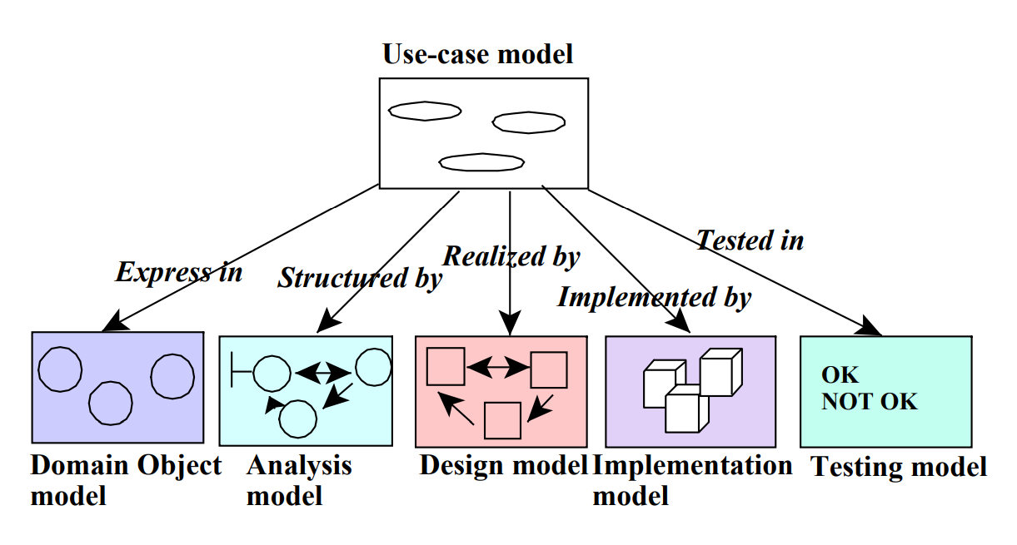
- Use Case Model:
  - The use case model defines the outside (actors) and inside (use case) of the system’ behavior.
- Domain Object Model:
  - The objects of the real world are mapped into the domain object model.
- Analysis object model:
  - The analysis model presents how the source code (implementation) should be carried out and written.
- Implementation Model:
  - The implementation model represents the implementation of the system.
- Test Model:
The test model constitutes the test plans, specifications and reports.
OR
20 a) Explain the Unified Modeling Language (UML) and its role in object-oriented
analysis and design.(14)
The Unified Modeling Language (UML) is a standardized modeling language that provides a comprehensive set of graphical notations for visualizing, specifying, constructing, and documenting the artifacts of software systems. It plays a crucial role in object-oriented analysis and design (OOAD) by enabling developers to effectively capture, communicate, and analyze the various aspects of an object-oriented system.
- The primary goals in the design of the UML were as follows:
1. Provide users a ready to use expressive visual modeling language so they can develop and exchange meaningful models.
2. Provide extensibility and specialization mechanisms to extend the core concepts.
3. Be independent of particular programming languages and development processes.
4. Provide a formal basis for understanding the modeling language.
5. Encourage the growth of the OO tools market.
6. Support higher-level development concepts.
7. Integrate best practices and methodologies

UML diagrams separate into two groups:
Structural diagrams
Structural diagrams show a system's structure, implementation levels, individual parts and how these components interact to create a functional system. There are six kinds of structure diagrams, including:
- Class diagrams: Class diagrams are the foundational principle of any object-oriented software system, and depict classes and sets of relationships between classes. The classes within a system or operation depict its structure, which helps software engineers and developers identify the relationship between each object.
- Component diagrams: These diagrams indicate the organizational structure of physical elements in a software system. They help engineers and developers understand whether the systems need additional improvements or if their original structure performs efficiently.
- Composite structure diagrams: This diagram shows the internal structure of a class and how it communicates with other parts of the system.
- Deployment diagrams: Deployment diagrams show software engineers and developers what hardware components are available and which type of software components can efficiently run them. They're beneficial when software is distributed or used across multiple machines with diverse configurations.
- Object diagrams: Object diagrams show the relationship between the functions in a system, along with their characteristics.
- Package diagrams: Packages are the various levels that may contribute to a system's architecture, and package diagrams help engineers and developers organize their UML diagrams into groups that make them easier to understand.
Behavioral diagrams
Behavioral diagrams show how a proper system should function. Explore these seven kinds of behavioral diagrams:
- Use case diagrams: A use case diagram shows the parts of the system or functionality of a system and how they relate to each other. It gives developers a clear understanding of how things function without needing to look into implementation details.
- Activity diagrams: These diagrams depict the flow of control in a system and may be useful as a reference to follow when executing a use case diagram. Activity diagrams can also depict the causes of a particular event.
- Sequence diagram: This diagram shows how objects communicate with each other sequentially. It's commonly used by software developers to document and understand the requirements needed to establish new systems or gain more knowledge about existing systems.
- Communication diagrams: The communication diagrams show the sequential exchange of messages between objects. These diagrams are similar to sequence diagrams, but communication diagrams offer more flexibility.
- Interaction overview diagram: This diagram uses different kinds of interaction programs to show the sequence of actions. These diagrams help developers change complex interactions into simple events.
- State machine diagrams: These diagrams describe how objects behave in different ways in their present state.
- Time diagram: Time diagrams are a type of sequence diagram used to show the behavior of objects over time. Developers use them to illustrate duration constraints and the time to control changes in objects' behavior.
There are three major benefits of UML:
- Improved communication: A UML enables developers to communicate on a topic that includes the system and its requirements. In this way, it can help professionals communicate with coworkers and among various teams.
- Clear model system: The UML model system uses a representation of the subject and a combination of a set of ideas to aid visual communication.
- Standardization: UML brings together technology and information systems and applies specific techniques to develop successful and standardized systems.

